1a. Write the line of code in toggle_g (1 mark)

GPIOC->ODR^= ODR(GREEN_LED);

1b. Which register is being modified in toggle_g ? (0.5 marks)

The register that was being modified was that of R0 a low general purpose register

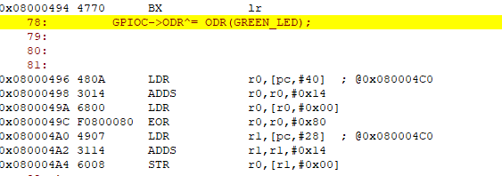

1c. For the register in q1(b), which bits were modified? (0.5 marks)

Bit 7 is the only one thats modified (the green LED is the one connected to pin 7)

1d. Write the line of code that sets JOY_UP as an input (1 mark)

GPIOA->MODER &= ~MODER(JOY_UP);

1e. Which register is being modified when setting JOY_UP as an input? (0.5 marks)

The register that was being modified was that of R0 a low general purpose register

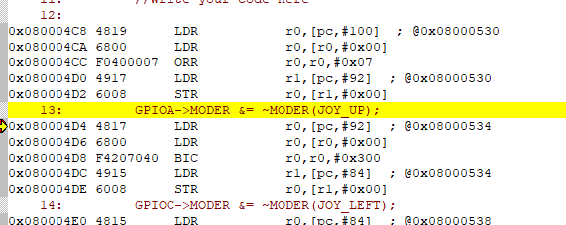

1f. For the register in q1(e), which bits were modified? (0.5 marks)

Both bits of MODER (GPIO A: 13, GPIO C: 14) -> set to 0

1g. Write the line of code that connects JOY_UP with EXTI4_IRQHandler (1 mark)

void EXTI4_IRQHandler(void){

NVIC_ClearPendingIRQ(EXTI4_IRQn);

if((GPIOA->IDR >> JOY_UP) & 0x1){

done = 3;

EXTI->PR |= (0x01 << JOY_UP);

}

}

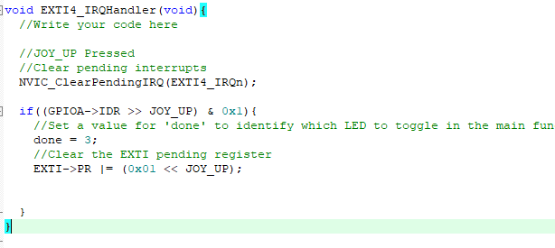

1h. Which register is being modified in q1(g)? (1 mark)

The register that was being modified was that of R0 a low general purpose register

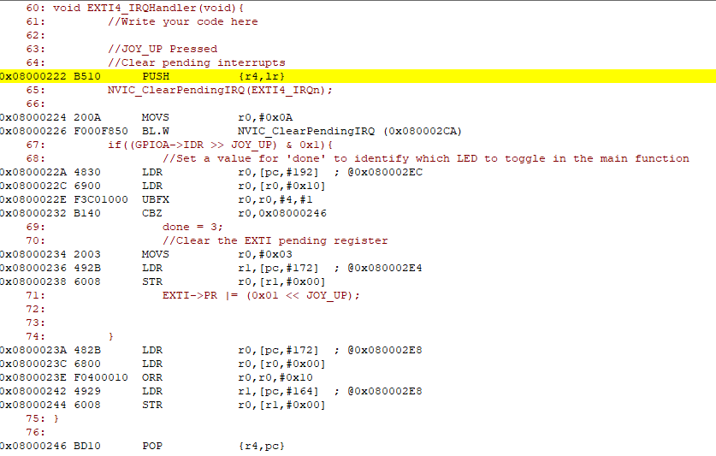

1i. Which bits were set to make the connection in q1(g) and what were they set to? (1 mark)

The bits to make the JOY_UP connection were 0:3 and were set to 0

2. Make a bulleted list of the steps the MCU automatically takes between receiving an interrupt request and servicing the interrupt. (2 marks)

1-Set priority level of required interrupt

2- Enable the interrupt on 1/0 device or specified pin

3- Enable the specific interrupt in the NVIC

4- Set address of ISR in the NVIC to allow for corresponding ISR to be properly executed

3a. What does the NVIC do? (1 mark)

NVIC stands for Nested Vectored interrupt controller. The purpose of this controller is to interface with the interrupt vector table in addition to enabling and disabling interrupts and setting various registers associated with the interrupt service routine.

3b. How many programmable priority levels does this NVIC have? (1 mark)

After consulting the Reference guide for the microcontroller used for the lab it can be stated that the NVIC has a total of 16 programmable priority levels

4a. (0.25 marks, numerical) What is the ISR number for EXTI0_IRQHandler?

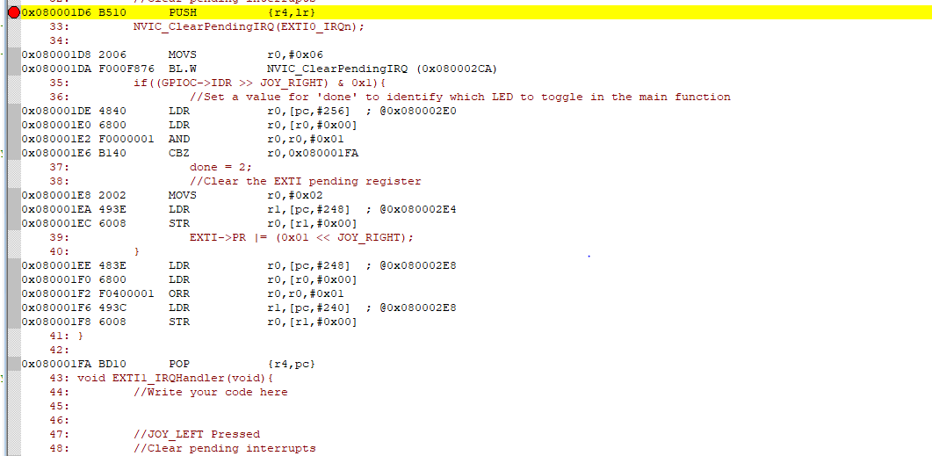

4b. (0.25 marks, numerical) What is the ISR number for EXTI1_IRQHandler?

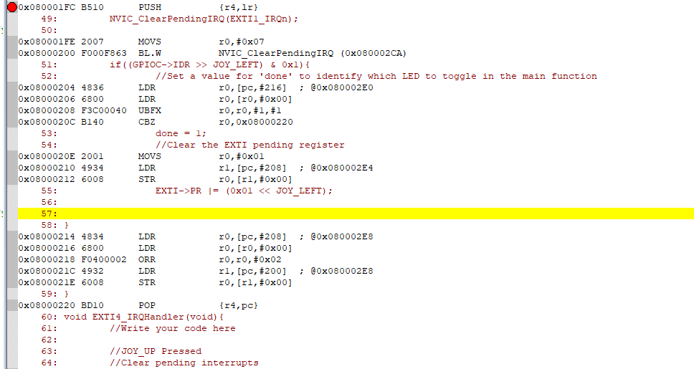

4c. (0.25 marks, numerical) What is the ISR number for EXTI4_IRQHandler?

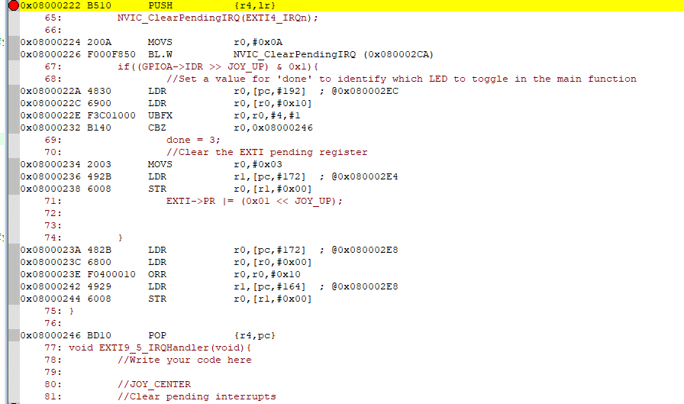

4d. (0.25 marks, numerical) What is the ISR number for EXTI9_5_IRQHandler?

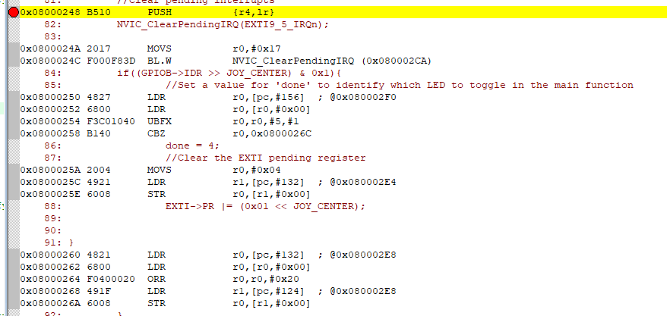

5a. What is the main stack pointer (MSP)? (0.5 marks)

It is the default stack pointer

5b. Use the disassembly shown inside Keil to help explain why and where the MSP changes throughout the course of the program. (1.5 marks)

6a. When is the processor in thread mode for this program?

The processor is in thread mode whenever it is not in the process of undergoing an ISR thus when the joystick is not being pressed.

6b. When is the processor in handler mode for this program?

The processor is in handler mode whenever an ISR is triggered so that would be everytime the joystick is pressed.

7a. What is a GPIO? (1 mark)

GPIO stands for General Purpose Input/ Output. It is a pin or set of pins that can function as an input to the MCU or an output from the MCU. The programmer is the one who must set them to either an output or an input.

7b. Looking in leds.c, why are the GPIO pins set to pull-down mode?

Used to configurer this pins to act as outputs to provide the current required to light up the leds

8a. What is the purpose of the “delay” function in main.c? (1 mark)

The purpose of the dealy is to provide simple debouncing for the joy stick so that when it was pressed in a specific direction it only triggered once.

8b. Why is the delay function called above the _wfi() call in main.c? (0.5 mark)

The delay function is called above the _wfi() in main because it allows the signal

8c. What is __wfi() and how does it appear in the disassembled code? (0.5 mark)

Wfi stands for what for interrupt and it appears as( 0x080002C6 BF30 WFI ) in the assembly code

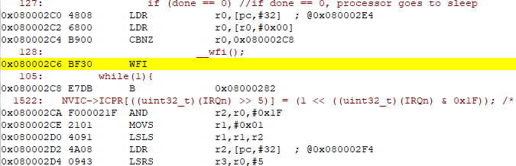

9. Find the toggle_g function in the disassembled code. Comment the assembly code and provide the commented assembly code. (2 marks).

LDR r0, [pc,#40 ] // load the value of the program counter offset by 40 from memory into the general purpose register r0

ADDS r0, r0,#0x14 // adds the immediate of 0x14 to the value contained in r0 and saves the results to r0

LDR r0 , [r0,#0x00] // load the value contained in memory address 0x00 into r0

EOR r0 , r0,r0,#0x80 // Exclusively or R0 with 0x80 and save result in R0

LDR r1, [pc,#28] // load the value of the program counter offset by 28 from memory into the general purpose register r0

ADDS r1 ,r1,#0x14 // adds the immediate of 0x14 to the value contained in r1 and saves the results to r1

STR r0 ,[r1,#0x00] // store the value contained in r1 at 0x00 in the register r0

